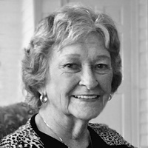
Bettye Cecil SCAPA Conference Scholarship
Bettye had a vision in 1989 and gathered a group of 28 Activity Professionals together to create the South Carolina Activity Professionals Association. By-laws were adopted and the organization began. The First President was Mae Vaughn and Bettye was the State Rep to NAAP. From that small band of Activity Professionals, SCAPA has grown to over 300 members and we had 143 registered for the March 2019 conference. I know Bettye would be overjoyed to see where her passion and hard work led, as she was a strong advocate for Activity Professionals as well as education. Bettye felt education was important, even back in 1989, and it is even more important today. We thank her so much for her vision and initiative to get this organization off the ground. She came to Myrtle Beach at the age of 80 in 2011 and helped us host the first ever National conference in SC. I know she was excited to be a part of that milestone.
On March 2, 2018, Bettye passed away peacefully at the age of 87, with her children by her side. I know we can all honor Bettye by being the best Activity Professionals we can be and to provide the best services and programs for those we serve.
To recognize Bettye’s service to SCAPA and to honor her memory, with her family’s permission, the SCAPA Board will be offering a Scholarship in Bettye’s name, for a SCAPA member Activity Professional to attend the annual conference in March of each year. A copy of the scholarship application is in this newsletter. If you would like to attend the conference and need financial assistance, please send it in!
SCAPA will continue to carry on Bettye’s legacy for many more years to come!

